Journal Entry is creating in two ways in Netsuite Application
1. Data entry
2. Importing csv file

1. Data entry
Step 1 | Login to NetSuite  Sandbox URL: https://fs.ada.org/adfs/ls/IdpInitiatedsignon.aspx →For Development and Testing  Production URL: To be updated once shared by business users post successful testing in Sandbox
Step 2 | Navigate to Transaction-> Financials-> Make Journal Entry-> List
Step 3 | Enter details in Primary Information Section  Business Rules:  - Customer Form will always be “ADA Journal Entry”  - Date will the date on which the Journal Entry is created  - Journal name will be monthBRIyyyy. (to do JE for that month report)  Example: AprilBRI2021  - Comments as “Reclassify BRI payments from bank statement”
Step 4 | Enter Details in Classification Section  Business Rules  - Subsidiary will always be ADA 501(C)(6)
Step 5 | Enter Details in Lines tab as per the excel report (Account, Cost Center, Program and Amount)  Business Rules:  - Account: 210306 Flexible Health Benefit (FSA Medical)/cost center :000000001 bal Sheet/Program: 0000001 Bal sheet/Description: FSA For April BRI 2021  - Account:210313 Parking Reimbursment W/H (Parking)/cost center :000000001 bal Sheet/Program: 0000001 Bal sheet/Description: Parking for April BRI 2021  - Account: 210307 Dependent care benefit (FSA Dep Care) /cost center :000000001 bal Sheet/Program: 0000001 Bal sheet/Description: FSA Dep Care For April BRI 2021  - Account: 125600 Travel benefit clearing (Transit) /cost center :000000001 bal Sheet/Program: 0000001 Bal sheet/Description: Parking for April BRI 2021  - Account: 101005 Chase /cost center :000000001 bal Sheet/Program: 0000001 Bal sheet/Description: April BRI 2021 from bank statement (Finally do entry for cash account
Step 6 | Total Amount in NetSuite must match the total amount in Excel report
Step 7 | Click on “View”
Step 8 | Amount for each plan in NetSuite should match the excel report
Step 9 | Navigate to “Communications” > “Files”
Step 10 | Upload the template prepared for journal entry  - Click on “+” icon and then click on “Browse” and Select the reconciled BRI report from the shared folder
Step 11 | Verify if the uploaded files are seen in “Communications” tab. Check the filename in the grid and
Step 12 | Click on “Save “button and Click the "Submit for Approval” button  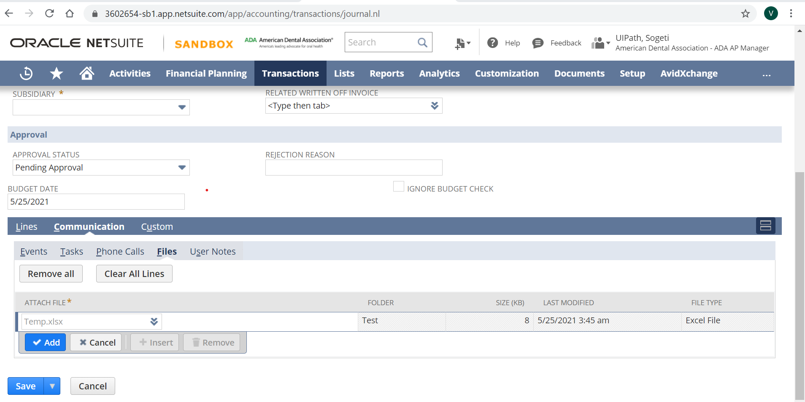
Step 13 | Log-off from the NetSuite Portal

2. Importing csv file

Step 1 | Login to NetSuite and create Journal Entry by Uploading the template created in Step 5  Sandbox URL: https://fs.ada.org/adfs/ls/IdpInitiatedsignon.aspx →For Development and Testing  Production URL: To be updated once shared by business users post successful testing in Sandbox  - Launch the NetSuite web application using Chrome browser  - Enter the login Credentials and Click on “Sign in” button  - Navigate through Set-up> ImportExport> Saved CSV Imports  This action will load the new page  - Scroll on the screen and click on “Journal Entry Import Template” against Id “192”  This action will load the new screen  - Click on “Select” button  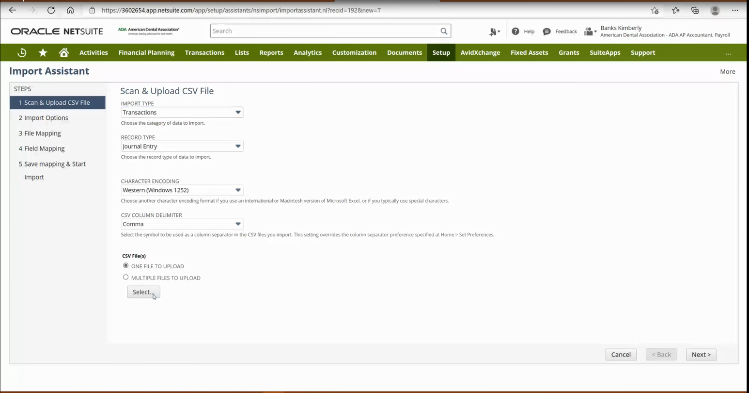  - Locate the template file saved on the Local folder and Click on “Open” button  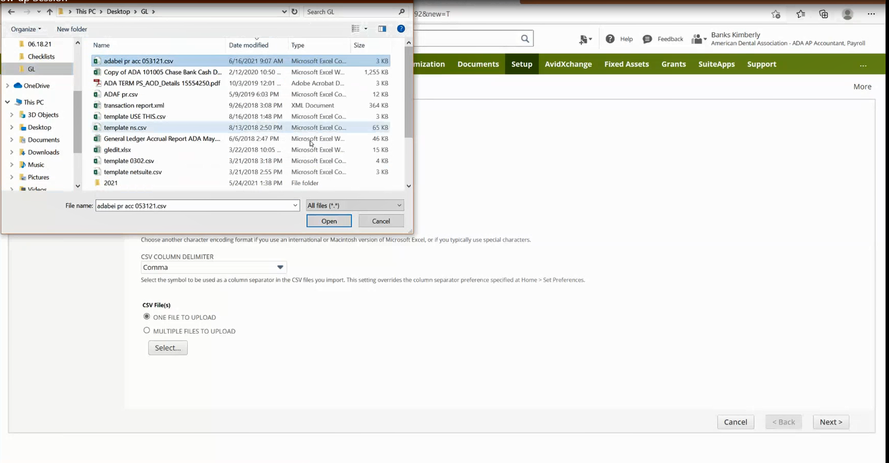  - Click on the “Next” button  This action will load a new screen  - Click on “Next”  This action loads the new screen  - Click on the “Next” button  - There will be pop-up with warning. Click on the “OK” button to proceed  This action loads the new screen  - Select the “Run” option from the drop-down list against the “Save As & Run” button  This action throws a pop-up message  - Click on the “OK” button  This action loads the screen confirming the import job is successfully completed  - Click the hyperlink “Import job status”  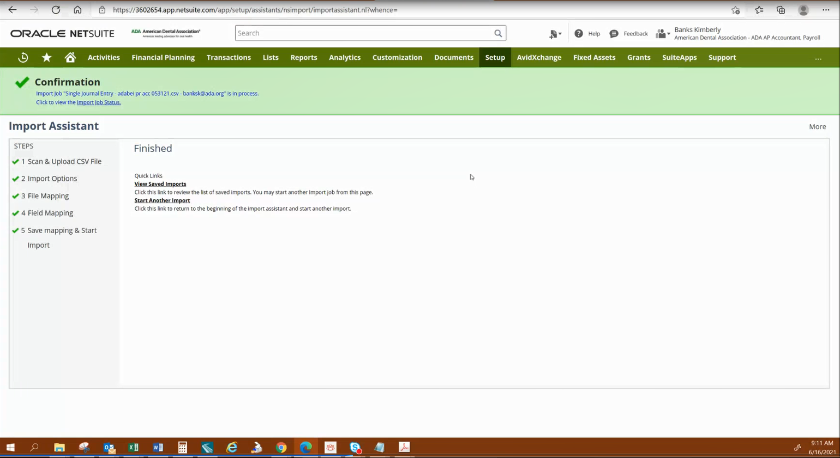  This action loads the new screen confirming the template file has successfully loaded into NetSuite  - Check for the file name, status and Message headers to confirm if the records from template file is successfully loaded and Journal Entry is successfully created and sent for Approval.  Note: There could be a situation when the file name appears to be correct and status is shown as “Complete”, however the message would display “0/1 records imported successfully”. This necessarily means the records from the template are not uploaded to NetSuite.  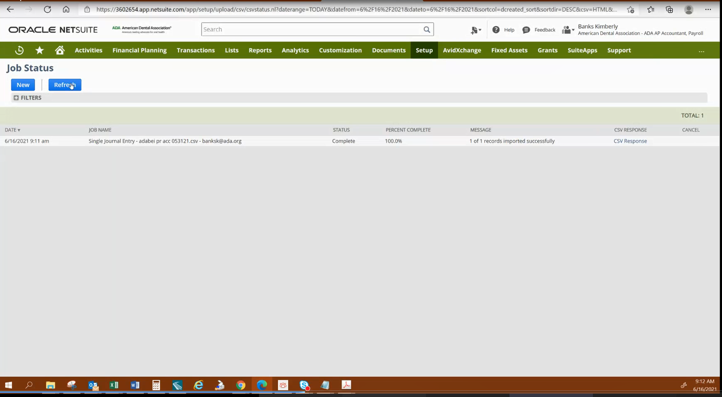
Step 2 | Upload the General Ledger Accrual Report against the Journal Entry created in Step 6  - Find the file by navigating through Transactions>Financial>Make Journal Entries>Search  This action loads a new page.  - Look for the entry recently created based on name of the file mentioned against the label MEMO(Main), Approval Status as “Pending Approval”  - Click on “Edit” button. This will load the new screen  Look if all the details like Journal Name, Comments, Reversal Date, Posting Period, Subsidiary, the Line items, Account, Cost Center, Program, Debit amount, Credit amount, Description etc. are correct  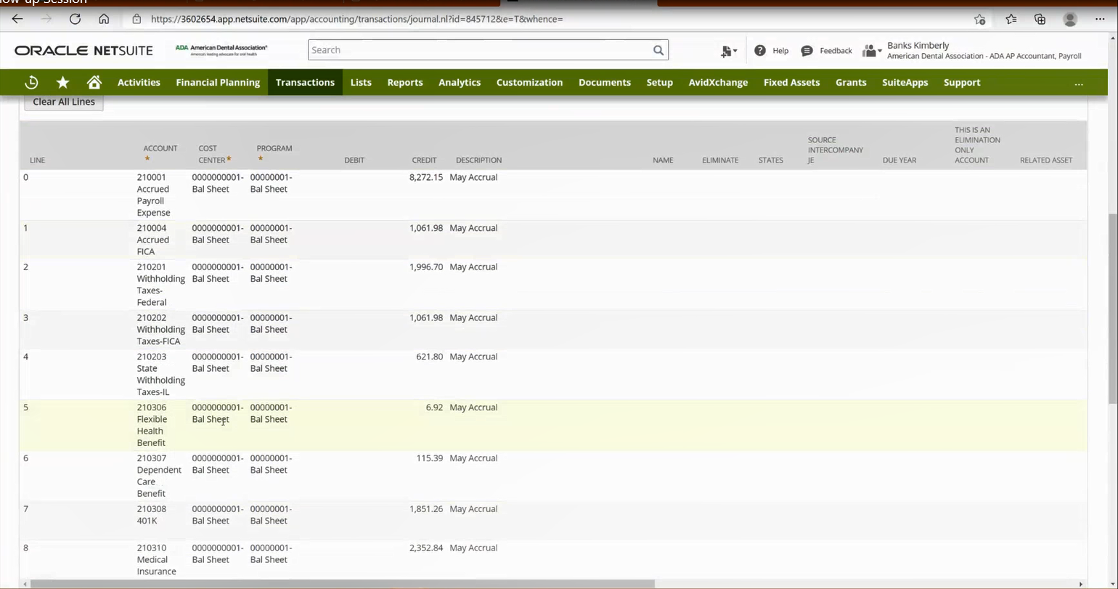  - Click on the icon besides Actions and then click on “File”  This will open a window to browse and attach the General Ledger Accrual report file  - Enter the filename as Company name acc mmddyy and click on “Choose file”  Example: adabei acc 053121  - Select the folder as “ADA Accounting: Accounts Payable” from the drop-down list  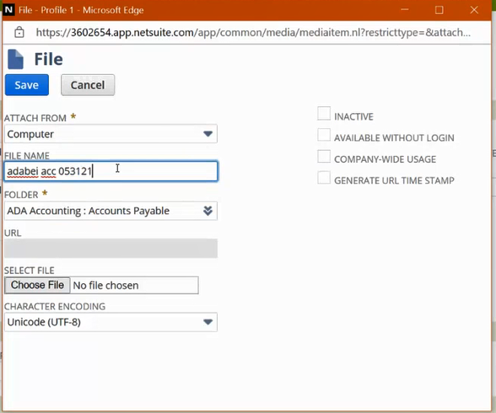  This action will open new window to select the file from the path where it is saved  - Select the file and click on “Open” button. The file is now attached to the Journal Entry  - Click on the “Save” button and then Click on “Submit for Approval” button  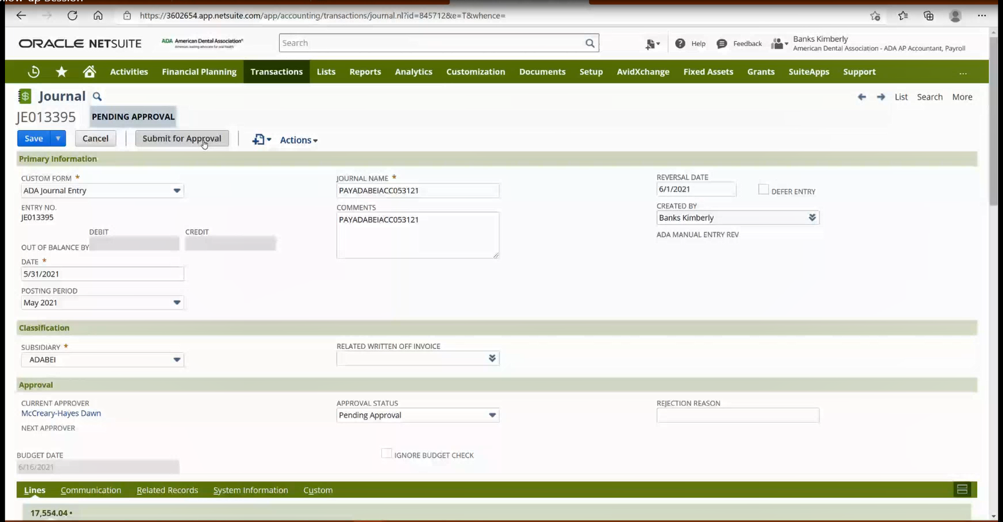
Step 3 | Log-off from the NetSuite Application

